Editorial

Neuroprotective effects of medicinal plants

Romij Uddin¹, Haeng Hoon Kim², Jai-Heon Lee³, Sang Un Park¹
¹Department of Crop Science, Chungnam National University, 99 Daehak-ro, Yuseong-gu, Daejeon, 305-764, Korea
²Department of Well-being Resources, Sunchon National University, 413 Jungangno, Suncheon, Jeollanam-do, 540-742, Korea
³Department of Genetic Engineering, Dong-A University, Busan 604-714, Korea

EXCLI J 2013;12:Doc541

⁯
As human life expectancy has increased, so too has the incidence of age-related neurodegenerative disorders such as Alzheimer's disease, Parkinson's disease, and Huntington's disease (Borgesius et al., 2011[4]). Plant extracts have a wide range of medicinal actions, and throughout history, they have been used to treat many different types of diseases. More recently, however, scientists have begun investigating the biological activities of medicinal plants, including their neuroprotective actions. For example Lycium chinense Miller, which is a traditional herbal medicine used in China, Korea, and Japan, has been shown to have hypotensive, hypoglycemic, and antipyretic effects in animal studies following treatment with the fruit and root bark of the plant (Potterat, 2010[19]; Lee et al., 2004[15]). Furthermore, this plant has been used as an anti-aging therapy and a treatment for neurodegenerative diseases (Ho et al., 2010[6]; Potterat, 2010[19]), and recent research has confirmed neuroprotective effects of the fruit of the plant in a rat model of trimethyltin-induced learning and memory impairment (Park et al., 2011[17]). Other plants have also shown neuroprotective effects. In separate studies, extracts of Camellia sinensis and Erigeron breviscapus demonstrated neuroprotective effects against hydrogen peroxide-induced toxicity in PC12 cells (López and Calvo, 2011[16]; Hong and Liu, 2004[8]), and Smilacis chinae Rhizome exhibited a neuroprotective effect in an in vitro model of N-methyl-d-aspartate-induced neurotoxicity; it showed a similar effect in an in vivo model of focal cerebral ischemia. Studies investigating the neuroprotective actions of various medicinal plants are shown in Table 1(Tab. 1) (References in Table 1: Bastianetto et al., 2000[2]; Koo et al., 2004[13]; Koo et al., 2004[12]; Yu et al., 2005[22]; Jia et al., 2005[9]; Bastianetto et al., 2006[3]; Ho et al., 2007[7]; Yun et al., 2007[23]; Ban et al., 2008[1]; Shim et al., 2009[20]; Kim et al., 2010[11]; Choi et al., 2011[5]; López and Calvo, 2011[16]; Park et al., 2011[18]; Lee et al., 2011[14]; Park et al., 2011[18]; Yao et al., 2011[21]; Keo et al., 2012[10]).

Notes
Jai-Heon Lee and Sang Un Park (Department of Crop Science, Chungnam National University, 99 Daehak-ro, Yuseong-gu, Daejeon, 305-764, Korea; Phone: +82-42-821-5730, E-mail: supark@cnu.ac.kr) contributed equally as corresponding authors.

References
1. Ban JY, Cho SO, Choi SH, Ju HS, Kim JY, Bae K, et al. Neuroprotective effect of Smilacis chinae rhizome on NMDA-induced neurotoxicity in vitro and focal cerebral ischemia in vivo. J Pharmacol Sci. 2008;106:68-77.
2. Bastianetto S, Ramassamy C, Doré S, Christen Y, Poirier J, Quirion R. The Ginkgo biloba extract (EGb 761) protects hippocampal neurons against cell death induced by beta-amyloid. Eur J Neurosci. 2000;12:1882-90.
3. Bastianetto S, Yao ZX, Papadopoulos V, Quirion R. Neuroprotective effects of green and black teas and their catechin gallate esters against beta-amyloid-induced toxicity. Eur J Neurosci. 2006;23:55-64.
4. Borgesius NZ, de Waard MC, van der Pluijm I, Omrani A, Zondag GC, van der Horst GT, et al. Accelerated age-related cognitive decline and neurodegeneration, caused by deficient DNA repair. J Neurosci. 2011;31:12543-53.
5. Choi JG, Kim HG, Kim MC, Yang WM, Huh Y, Kim SY, et al. Polygalae radix inhibits toxin-induced neuronal death in the Parkinson's disease models. J. Ethnopharmacol. 2011;134:414-21.
6. Ho YS, So KF, Chang RC. Anti-aging herbal medicine--how and why can they be used in aging-associated neurodegenerative diseases? Ageing Res Rev. 2010;9:354-62.
7. Ho YS, Yu MS, Lai CS, So KF, Yuen WH, Chang RCC. Characterizing the neuroprotective effects of alkaline extract of Lycium barbarum on beta-amyloid peptide neurotoxicity. Brain Res. 2007;1158:123–34.
8. Hong H, Liu GQ. Protection against hydrogen peroxide-induced cytotoxicity in PC12 cells by scutellarin. Life Sci. 2004;74:2959-73.
9. Jia RR, Gou YL, Ho LS, Ng CP, Tan NH, Chan HC. Anti-apoptotic activity of Bak Foong Pills and its ingredients on 6-hydroxydopamine-induced neurotoxicity in PC12 cells. Cell Biol Int. 2005;29:835–42.
10. Keo S, Lee DS, Li B, Choi HG, Kim KS, Ko WM, et al. Neuroprotective effects of Cambodian Plant extracts on glutamate-induced Cytotoxicity in HT22 cells. Nat Prod Sci. 2012;18:177-82.
11. Kim HG, Ju MS, Shim JS, Kim MC, Lee SH, Huh Y, et al. Mulberry fruit protects dopaminergic neurons in toxin-induced Parkinson's disease models. Br J Nutr. 2010;104:8-16.
12. Koo BS, Kim YK, Park KS, Chung KH, Kim CH. Attenuating effect of a traditional korean formulation, Paeng-Jo-Yeon-Nyeon-Baek-Ja-In-Hwan (PJBH), on hydrogen peroxide-induced injury in PC12 cells. Phytother Res. 2004;18:488-93.
13. Koo BS, Lee WC, Chung KH, Ko JH, Kim CH. A water extract of Curcuma longa L. (Zingiberaceae) rescues PC12 cell death caused by pyrogallol or hypoxia/ reoxygenation and attenuates hydrogen peroxide induced injury in PC12 cells. Life Sci. 2004;75:2363-75.
14. Lee B, Choi EJ, Lee EJ, Han SM, Hahm DH, Lee HJ, et al. The neuroprotective effect of methanol extract of gagamjungjihwan and fructus euodiae on ischemia-induced neuronal and cognitive impairment in the rat. Evid Based Complement Alternat Med. 2011;2011:685254. doi: 10.1093/ecam/nep028. Epub. 2011 Mar 10.
15. Lee DG, Park Y, Kim MR, Jung HJ, Seu YB, Hahm KS, et al. Anti-fungal effects of phenolic amides isolated from the root bark of Lycium chinense. Biotechnol Lett. 2004;26:1125-30.
16. López V, Calvo MI. White tea (Camellia sinensis Kuntze) exerts neuroprotection against hydrogen peroxide-induced toxicity in PC12 cells. Plant Foods Hum Nutr. 2011;66:22-6.
17. Park HJ, Shim HS, Choi WK, Kim KS, Shim I. Neuroprotective effect of Lucium chinense fruit on Trimethyltin-Induced learning and memory deficits in the rats. Exp Neurobiol. 2011;20:137-43.
18. Park HJ, Shim HS, Kim KS, Shim I. The protective effect of black Ginseng against transient focal ischemia-induced neuronal damage in rats. Korean J Physiol Pharmacol. 2011;15:333-8.
19. Potterat O. Goji (Lycium barbarum and L. chinense): Phytochemistry, pharmacology and safety in the perspective of traditional uses and recent popularity. Planta Med. 2010;76:7-19.
20. Shim JS, Kim HG, Ju MS, Choi JG, Jeong SY, Oh MS. Effects of the hook of Uncaria rhynchophylla on neurotoxicity in the 6-hydroxydopamine model of Parkinson's disease. J Ethnopharmacol. 2009;126:361-5.
21. Yao XL, Wu WL, Zheng MY, Li W, Ye CH, Lu XL. Protective effects of Lycium barbarum extract against MPP(+) -induced neurotoxicity in Caenorhabditis elegans and PC12 cells. Zhong Yao Cai. 2011;34:1241-6. [Article in Chinese].
22. Yu MS, Leung SK, Lai SW, Che CM, Zee SY, So KF, et al. Neuroprotective effects of anti-aging oriental medicine Lycium barbarum against beta-amyloid peptide neurotoxicity. Exp Gerontol. 2005;40:716–27.
23. Yun YJ, Lee B, Hahm DH, Kang SK, Han SM, Lee HJ, et al. Neuroprotective effect of palmul-chongmyeong-tang on ischemia-induced learning and memory deficits in the rat. Biol Pharm Bull. 2007;30:337-42.

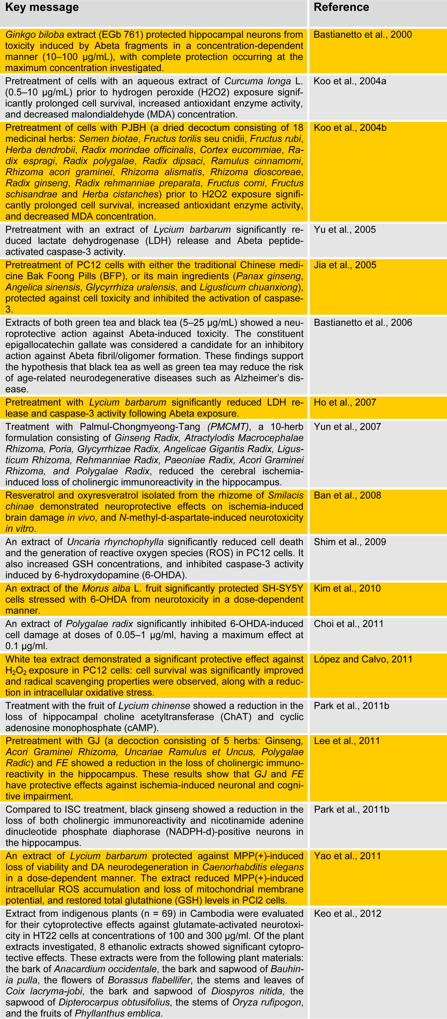
Table 1: Studies investigating the neuroprotective effects of medicinal plants

Corresponding Author: Jai-Heon Lee, Department of Genetic Engineering, Dong-A University, Busan 604-714, Korea; Phone: + 82-51-200-7592, eMail: jhnlee@dau.ac.kr

